Lesson 20 – Maths for Data Analysis – Sample Solutions
Download the election_results.csv, hours_studied.csv, and monthly_game_sales.csv files from Brightspace. Use that data set for these examples.
------------------------------------------------------------------------------------------------------------------
Using election_results.csv, describe the steps necessary to find the percentage of the vote won by the victor in any given riding as a percentage. Provide the solution for the Yellowknife riding to the first decimal place.
- Divide the VotesForVictor value by the TotalVotes value
- Multiple the result by 100 to give the percentage
- Yellowknife:
  - VotesForVictor = 7123
  - TotalVotes = 12345
  - P(X) = 7123 / 12345
  - P(X) = 0.577
  - Percentage = 0.577 x 100
  - The NDP won 57.7% of the vote in Yellowknife

------------------------------------------------------------------------------------------------------------------
Using medical_data.csv, identify the likelihood that a positive test result will match a positive actual result and a negative test result will match a negative actual result. In the dataset, a 1 is a positive result and a 0 is a negative result.
Describes the steps and calculations used to reach this conclusion. Provide screenshots of any usage of Excel.
- Select the ActualCondition and TestResult columns in Excel to create a pivot table.
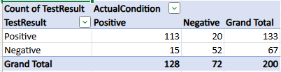
- Positive Result:
  - PositiveMatches / TotalPositiveTests
  - Probability = 113 / 133
  - Probability = 0.849
  - Likelihood = P(X) / 1 – P(X)
  - Likelihood = 0.849 / 0.151
  - Likelihood = 5.623
- Negative Result:
  - NegativeMatches / TotalNegativeTests
  - Probability = 52 / 67
  - Probability = 0.776
  - Likelihood = P(X) / 1 – P(X)
  - Likelihood = 0.776 / 0.224
  - Likelihood = 3.464
------------------------------------------------------------------------------------------------------------------
Using medical_data.csv, determine if there is a correlation between the age of a patient and a positive result. Include:
- The steps to find this correlation, including any screenshots from Excel if used.
- The r-value
- Whether the correlation is positive, negative, or independent (no correlation).
- The strength of the relationship
- Is the relationship causal? Why or why not?

- Select an empty cell and add the CORREL function to it for the ActualCondition and Age columns
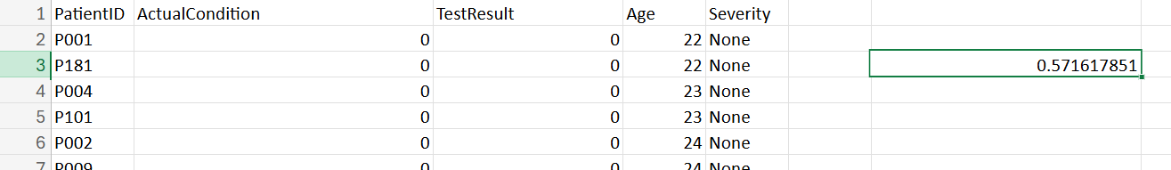
- The r-value is 0.572, which shows a moderate positive correlation.
- The data show that older people have an increased chance of getting this disease. There is a likely causal relationship since it is known that older people tend to get more illnesses, but further analysis would be required to confirm this.
------------------------------------------------------------------------------------------------------------------
Using toy_sales.csv, identify potential trends in the data. Provide steps to achieve these claims.
- Trend 1: There is a noticeable rise in toy sales from the months of October to December.
  - Use the data in the Month column and the Revenue column to create a line chart.
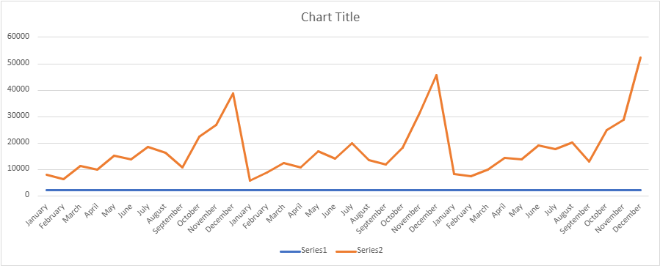
  - Based on this, one trend that can be viewed is that as Christmas approaches, people tend to buy more toys for Christmas gifts.
- Trend 2: The number of units sold is increasing over time.
  - Use the Year column and Units Sold column to generate a pivot table and pivot chart
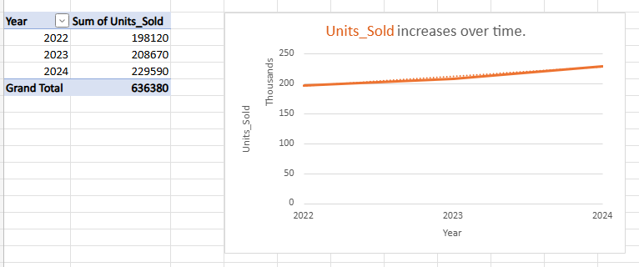
  - Each subsequent year there is an increase in the number of toys purchased. There could be many causal factors for this:
    - The population of the region is growing, meaning there are more people buying toys.
    - The economy is doing well, meaning that there is more money to buy toys.
    - The cost of producing toys decreased so more toys can be purchased for the same amount of money.

